Interest Calculation Sum

1. Apr 01 Goods purchased from M/s. MORE INDUSTRIALS for the following

Horlicks : 300bottles @ Rs.180each

Cerelac : 500pack @ Rs.200each

Bornvita : 400bottels @ Rs.200each Vide bill no: 90(30days)

Rate of interest: 15%

Interest style: 365days

Interest balance: Debit Balance

Applicability: Past due date By: 30days

From: Due date of invoice ref

1. Apr 02 Goods sold to M/s. WORLD VISION for the following

Horlicks : 200bottles @ Rs.210each

Cerelac : 250pack @ Rs.220each

Bornvita : 200bottels @ Rs.250each Vide bill no: 080

Rate of interest: 10%

Interest style: 365days

Interest balance:: All balance

Applicability: Past due date By: 30days

From: Due date of invoice ref

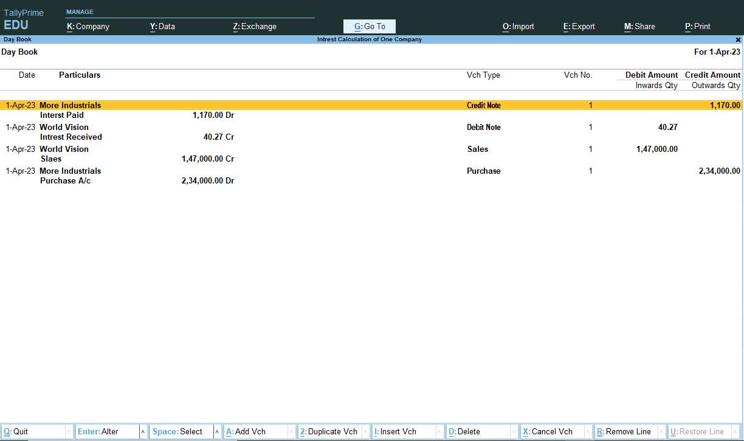

Project complete